**Burkina_Faso – PiN insight**

## **Children in Need (5-17 y.o.)**

**34.6% (i.e. 23.8M)** of school-aged children are in need. Among them:

* 10.5M are girls and 13.3M are boys;
* 2.4M are 5 years old (ECE);
* 2.4M are children with disability.

School-aged children in need, according to population groups:

|  |  |
| --- | --- |
| Population groups | Number of school-aged children in need of education |
| NON_PDI | 12.6M |
| PDI | 11.1M |
| TOTAL | 23.8M |

Additionally, X of adults (teachers/educational staff) are in need of education assistance.

### School-aged children severity distribution

|  |  |  |  |  |  |  |  |  |
| --- | --- | --- | --- | --- | --- | --- | --- | --- |
|  |  |  | School-aged children PiN | | | | | |
| ToT # | Severity levels 1-2 | | Severity level 3 | | Severity level 4 | | Severity level 5 | |
|  | % | # | % | # | % | # | % | # |
| 68.7M | 65.4 | 44.9M | 33.4 | 22.9M | 1.3 | 858K | 0.0 | 8K |

### Unpacking levels of severity for each population group

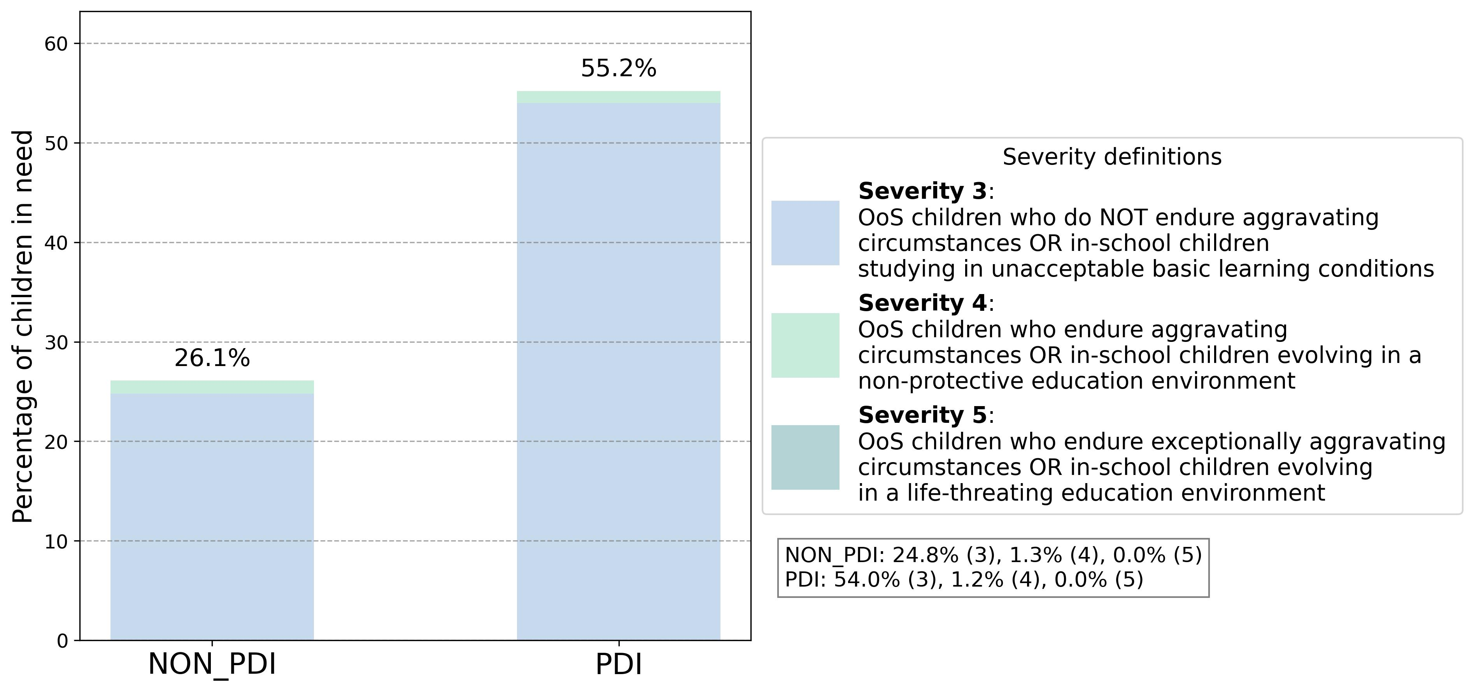

### Unpacking children needs

Considering only the children in need, it is possible to explore the needs driving the severity.

|  |  |  |
| --- | --- | --- |
| **Among the all children in need (23.8M):** | % | # |
| Lack access to school | 95.3% | 22.6M |
| Study in unacceptable basic learning conditions | 1.1% | 258K |
| Evolve in a non-protective education environment | 3.3% | 791K |
| Face aggravating circumstances preventing their access to education | 0.3% | 75K |

|  |  |  |
| --- | --- | --- |
| **Among the NON_PDI children in need (12.6M):** | % | # |
| Lack access to school | 93.5% | 11.8M |
| Study in unacceptable basic learning conditions | 1.6% | 200K |
| Evolve in a non-protective education environment | 4.5% | 571K |
| Face aggravating circumstances preventing their access to education | 0.4% | 52K |

|  |  |  |
| --- | --- | --- |
| **Among the PDI children in need (11.1M):** | % | # |
| Lack access to school | 97.3% | 10.8M |
| Study in unacceptable basic learning conditions | 0.5% | 58K |
| Evolve in a non-protective education environment | 2.0% | 219K |
| Face aggravating circumstances preventing their access to education | 0.2% | 23K |

### Children's profile (from MSNA, HH survey)

The graphics below shows school-aged children profile, relying on the 4 dimensions of the education PiN (ALPA, Access to education, Learning conditions, Protection level in or on the way to school and Aggravating circumstances).

